OS & SP
Name : M Ramya Sree Roll No : 2520030094
Practical – 05
Producer-Consumer using Anonymous Pipe :
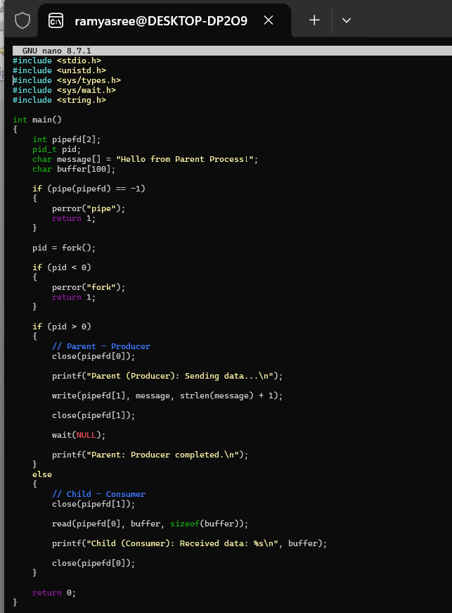
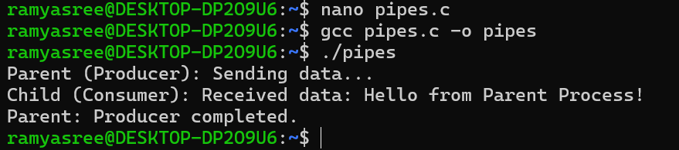
Ls_grep :
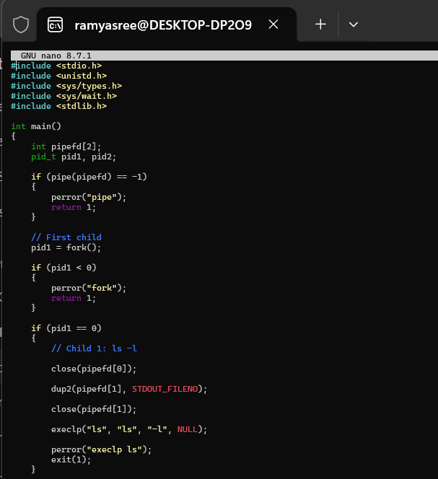
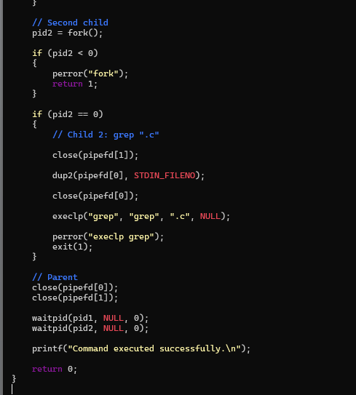
Output :
